Assignment module 3 : Understanding and Maintenance of Networks
Section 1: Multiple Choice
1. What is the primary function of a router in a computer network?
a) Assigning IP addresses to devices
b) Providing wireless connectivity to devices
c) Forwarding data packets between networks
d) Managing user authentication and access control
Answer :- c) Forwarding data packets between networks
2. What is the purpose of DNS (Domain Name System) in a computer
network?
a) Encrypting data transmissions for security
b) Assigning IP addresses to devices dynamically
c) Converting domain names to IP addresses
Answer :- c) Converting domain names to IP addresses
3. What type of network topology uses a centralized hub or switch to
connect all devices?
a) Star
b) Bus
c) Ring
d) Mesh
Answer :- a) Star
4. Which network protocol is commonly used for securely accessing and
transferring files over a network?
a) HTTP
b) FTP
c) SMTP
d) POP3
Answer :- b) FTP

Section 2: True or False

5. A firewall is a hardware or software-based security system that monitors and controls incoming and outgoing network traffic based on predetermined security rules. True
6. DHCP (Dynamic Host Configuration Protocol) assigns static IP addresses to network devices automatically. False
7. VLANs (Virtual Local Area Networks) enable network segmentation by dividing a single physical network into multiple logical networks. True
Section 3: Short Answer

8. Explain the difference between a hub and a switch in a computer Network.
Answer :-
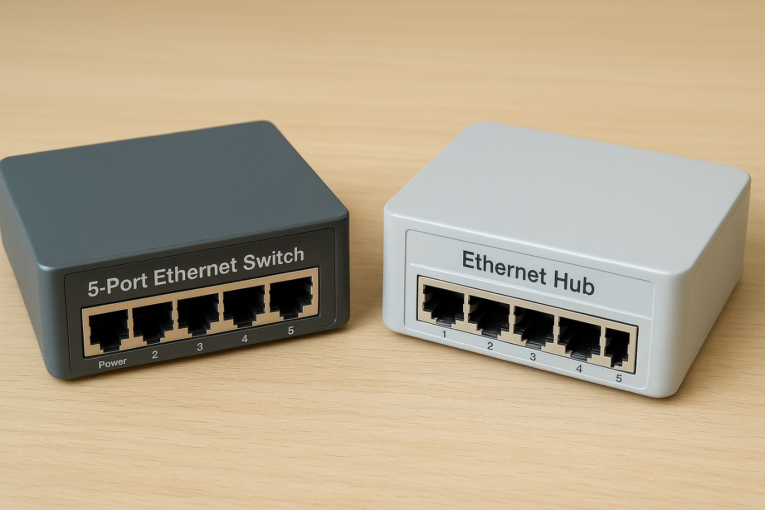
Difference | Hub | Switch
- Function | Broadcasts data to all ports | Sends data only to the destination port
- Data Transmission Method | Broadcast | Unicast, Multicast, or Broadcast
- Intelligence | Not intelligent — doesn’t check destination address | Intelligent — uses MAC address table to identify destination
- Network Traffic | Creates more traffic due to unnecessary data transmission | Reduces traffic by sending data only where needed
- Data Collisions | High chances of data collisions | Very low or no collisions (uses full duplex)
- Speed | Generally 10/100 Mbps | Can be 10/100/1000 Mbps or higher
- Port Communication | Half-duplex (data flows one way at a time) | Full-duplex (data flows both ways simultaneously)
- Cost | Cheaper | More expensive
- Use Case | Small or simple networks | Modern and large networks
9. Describe the process of troubleshooting network connectivity issues.
Answer :-
Troubleshooting network connectivity involves a systematic process of identifying the problem, checking hardware, verifying network settings, using diagnostic tools, and escalating if necessary. Start by defining the problem and checking physical connections, then use ipconfig to check IP configuration and ping/tracert to test connectivity to the default gateway and external sites. Next, perform a DNS check using nslookup and ensure no issues exist with malware or antivirus software. If the problem persists, check for ISP outages and consider more advanced tools or logs.
1. Define the problem and check physical connections
- Identify the issue: Clearly define the problem (e.g., slow speeds, no internet) and ask questions about what has changed recently, say YouTube users.
- Restart devices: Rebooting the modem, router, and computer can resolve many simple issues.
- Check hardware: Ensure all cables are securely plugged in and devices like routers and switches are powered on.
2. Check network configuration
- Verify IP configuration:
Open the command prompt and run ipconfig.
  - If the IP address starts with 169.254, the device has a duplicate IP address and is not getting a valid one.
- Confirm a valid IP:
Ensure the computer has a valid IP address, a subnet mask, a default gateway (router's IP address), and DNS servers.
3. Test connectivity
- Ping the default gateway:
Open the command prompt and enter ping [default gateway IP] to check if you can reach your router.
- Ping an external site:
Try pinging a public server like ping 8.8.8.8 to test your internet connection outside your local network.
- Trace the route:
Use the tracert command to see the path packets take to reach a destination and identify where the connection is failing.
4. Perform a DNS check
- Use nslookup:
Run nslookup [domain name] to see if you can resolve a domain name to an IP address.
- Identify DNS server issues:
If nslookup fails with errors like "timed out" or "server failure," the problem might be with the DNS server.
5. Address potential software issues
- Check security software: Ensure your antivirus or firewall isn't blocking the connection.
- Look for malware: Run a scan to check for any malicious software affecting network performance.
6. Contact the ISP
- If all local checks pass, contact your Internet Service Provider to see if there are any outages in your area
.
Section 4: Practical Application

- Demonstrate how to configure a wireless router's security settings to enhance network security.

Answer :-

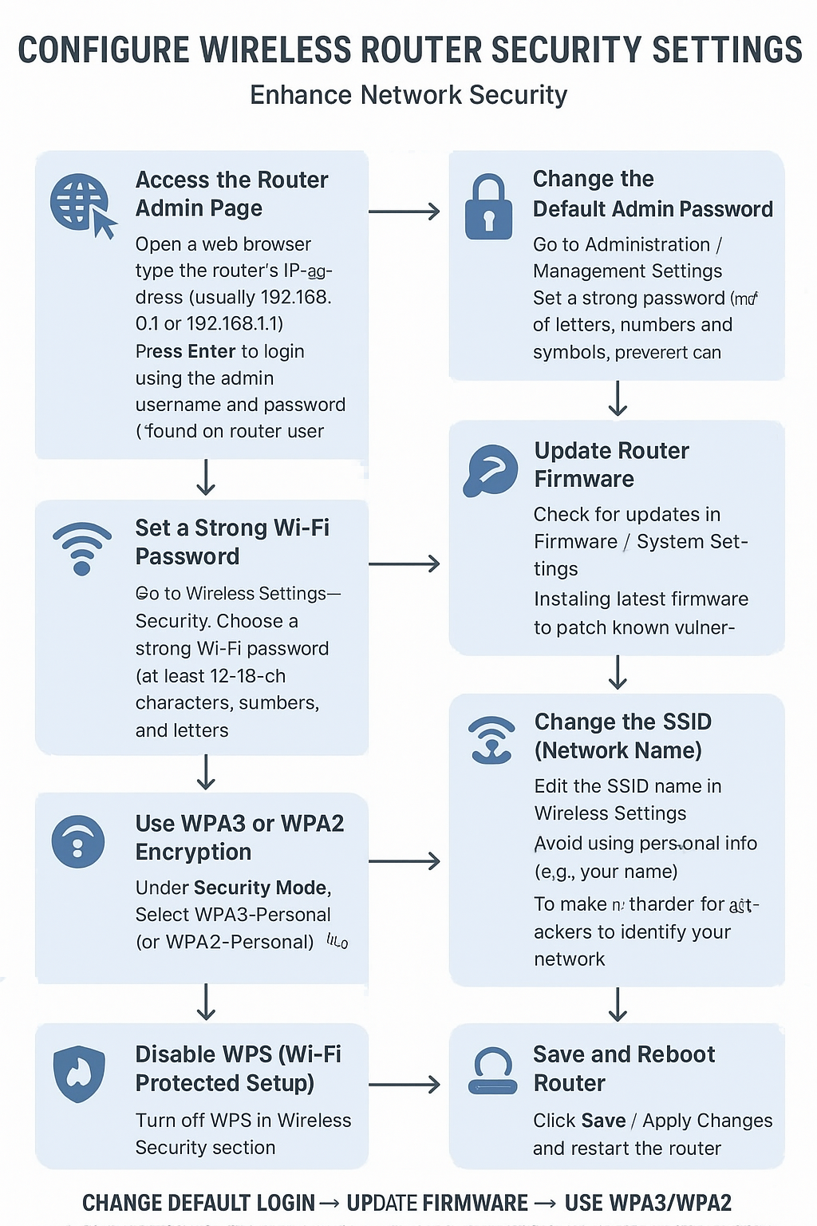

Section 5: Essay

11. Discuss the importance of network documentation and provide examples of information that should be documented.
Answer :-
Network documentation is the process of recording detailed information about a computer network’s design, devices, configurations, and connections. It plays a crucial role in network management, troubleshooting, and security.

🧠 Importance:
Reason | Explanation
1. Easier Troubleshooting | Helps network engineers quickly identify and fix problems by knowing how devices are connected and configured.
2. Better Network Management | Keeps track of IP addresses, routers, switches, and access points—avoiding confusion or duplication.
3. Security and Compliance | Maintains records for audits, ensures access controls are followed, and tracks changes for accountability.
4. Simplifies Upgrades and Expansion | When upgrading or adding new devices, documentation helps plan without disrupting existing systems.
5. Knowledge Transfer | New IT staff can easily understand the network layout and configurations through existing documentation.
6. Disaster Recovery | In case of system failure, accurate documentation allows quick restoration of network functionality.

📋 Examples of Information to Document
Category | Examples of What to Include
Network Topology | Diagram showing routers, switches, servers, and connections.
IP Address Scheme | List of device names, IP addresses, subnet masks, and gateways.
Device Information | Model numbers, serial numbers, MAC addresses, and firmware versions.
Configuration Settings | Backup copies of router, firewall, and switch configurations.
Cabling Information | Cable types, port numbers, and patch panel mappings.
User Access Information | Administrator login details, user permissions, and roles.
Security Policies | Firewall rules, VPN configurations, and Wi-Fi encryption details.
Maintenance Logs | Dates of updates, repairs, and replacements.
Vendor/Support Details | Supplier names, contact info, and warranty periods.

✅ Summary:
Network documentation ensures the network runs efficiently, stays secure, and can be quickly repaired or expanded when needed.

